Task Planning Template

Student |  | Date
Professor |  | Program #

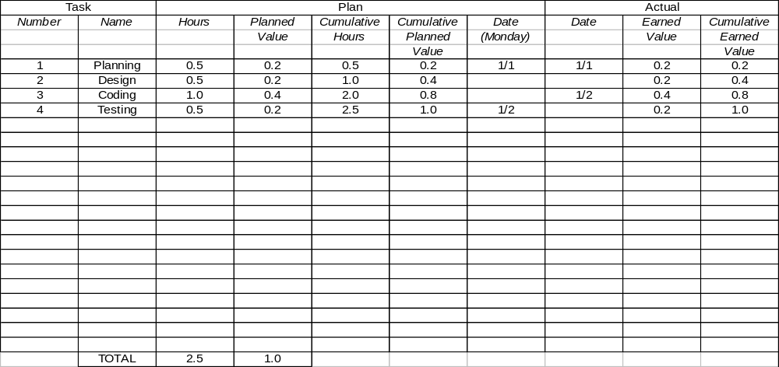
Task Planning Template Instructions

Purpose | - To estimate the development time for each project task  - To compute the planned value for each project task  - To estimate the planned completion date for each task  - To provide a basis for tracking schedule progress even when the tasks are not completed in the planned order
General | - Expand this template or use multiple pages needed.  - Include every significant task.  - Use task names and numbers that support the activity and are consistent with the project work breakdown structure.
Header | Enter the following:  - Your name  - Today’s date  - The professor’s name  - The project name or program number
Task | - Enter a task number and name. List the tasks in the order in which you expect to complete them.  - Select tasks that have explicit completion criteria, for example, planning completed, program compiled and all defects corrected, testing completed and all defects corrected, and so on.
Plan – Hours | Enter the planned hours for each task.
Plan – Planned Value | - Total the planned hours for all the tasks.  - For each task, calculate the percentage its planned hours are of total hours.  - Enter this percentage as the planned value for that task.  - The total planned value should equal 100.
Plan – Cumulative Hours | Enter the cumulative sum of the planned hours down through each task.
Plan – Cumulative Value | - Sum the planned values through each task.  - Before proceeding, complete the Schedule Planning Template down through Plan – Cumulative Hours.  - Then complete the Schedule Planning and Task Planning templates together.
Plan Date – Monday | - For each cumulative hours entry, find the planned cumulative hours entry on the Schedule Planning Template that equals or just exceeds it.  - Enter the date from that row (of the Schedule Planning Template) as the plan date on the Task Planning Template.  - If several weeks on the Schedule Planning Template have the same cumulative value, enter the earliest date.  - Unless you made daily plans, pick the plan date as the Monday of the week during which completion for that task is planned.
Actual Date | As each task is completed, enter the completion date.
Earned Value | For each completed task, enter the planned value.
Cumulative Earned Value | As each task is completed, total all the earned value entries and enter that total beside the latest task that was completed.

Schedule Planning Template

Student |  | Date
Professor |  | Program #

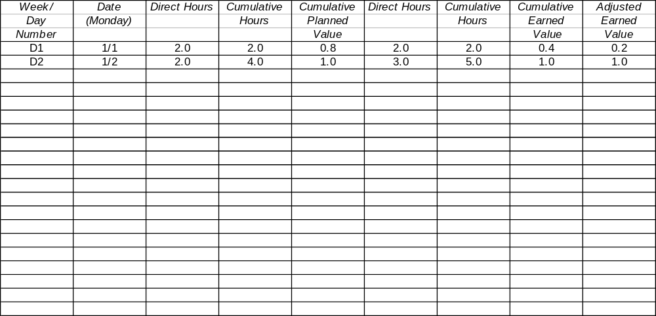
Schedule Planning Template Instructions

Purpose | - To record the estimated and actual hours expended by calendar period  - To relate the task planned value to the calendar schedule  - To calculate adjusted planned and earned values when tasks change
General | - Expand this template or use multiple pages needed.  - Complete it in conjunction with the Task Planning Template.
Header | Enter the following:  - Your name  - Today’s date  - The professor’s name  - The project name or program number
Week Number | - From the project start, enter a week number, typically starting with 1.  - For very small projects, it may be more convenient to use days instead of weeks.
Date (Monday) | - Enter the calendar date for each week.  - Pick a standard day in the week, for example, Monday.
Plan – Direct Hours | - Enter the planned number of direct project hours you expect to spend each week.  - Consider non-work time such as vacations, holidays, and so on.  - Consider other committed activities such as classes, meetings, and other projects.
Plan – Cumulative Hours | Enter the cumulative planned hours through each week.
Plan – Cumulative Planned Value | For each week do the following:  - Take the plan cumulative hours from the Schedule Planning Template.  - On the Task Planning Template, find the task with the nearest equal or lower plan cumulative hours and note its plan cumulative value.  - Enter this cumulative value in the Schedule Planning Template for that week.  - If the cumulative value for the prior week still applies, enter it again.
Actual | - During development, enter the actual direct hours, cumulative hours, and cumulative earned value for each week.  - Determine status against plan by comparing the cumulative planned value and the actual cumulative earned value.
Adjusted Earned Value | Proportionately adjust the earned value up or down as tasks are added or deleted. The adjusted earned value compensates for these changes without requiring a complete new plan.

